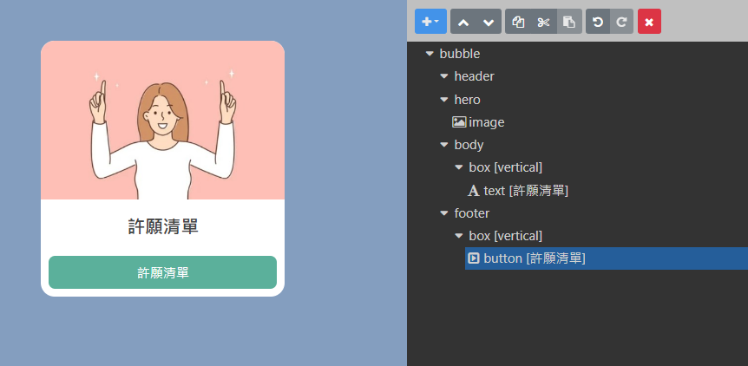

{

"type": "bubble",

"hero": {

"type": "image",

"aspectRatio": "20:13",

"url": "https://i.imgur.com/rZ6Wic2.jpg",

"align": "center",

"margin": "none",

"animated": true,

"aspectMode": "cover",

"size": "full",

"offsetTop": "none"

},

"body": {

"type": "box",

"layout": "vertical",

"contents": [

{

"type": "text",

"text": "許願清單",

"weight": "bold",

"size": "xl",

"align": "center"

}

]

},

"footer": {

"type": "box",

"layout": "vertical",

"spacing": "md",

"contents": [

{

"type": "button",

"style": "primary",

"action": {

"type": "message",

"text": "【報表管理】許願清單",

"label": "許願清單"

},

"height": "sm",

"color": "#5bb09b",

"offsetTop": "none"

}

],

"flex": 0,

"margin": "sm"

}

}